Report :"sword and fruits”

· **Purpose of the report:**

* The purpose of this report is to present a development plan for a VR game called **"Sword and Fruits"**, where the player uses a virtual sword to slice flying fruits.
* **Game parts and characters:**
* Number of players: Single player.

Characers:

* Player (uses the sword).
* Fruits (objects to slice).
* Bombs (appear in advanced levels and must be avoided).

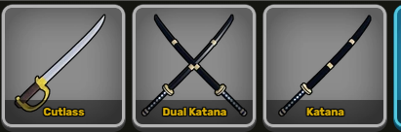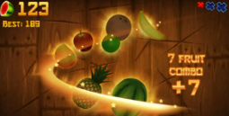

· **Game levels:**

**Level 1:** Slice 10 fruits within the time limit.

**Level 2:** Increased speed and 20 fruits.

**Level 3:** Bombs appear – slice 30 fruits and avoid bombs.

**Win:** Slice all required fruits.

**Lose:** Miss fruits or hit a bomb.

· **Game scenes:**

1-Main Menu

2-Play Scene

3-Win Scene

4-Game Over Scene

5-Options Screen

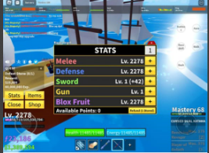

* **Game controls:**
* Movement: Using VR controller or arrow keys (right – left – up – down).
* Slice fruits: By swinging the virtual sword or pressing a control button.
* Activate switch (like example 3): By pressing an in-game button to enable a feature like "time freeze" or "speed boost".
* **Time plan:**
* Each day is assigned a task (design – code – test – polish – deliver).